  - Library Management System
  - Project Overview & Documentation
React Frontend • ASP.NET Core Web API • Entity Framework.
What is this project about?
The Library Management System is a full-stack web application designed to manage the daily operations of a library. The backend is organized using an ASP.NET Core API architecture utilizing Entity Framework Core for data access. The system tracks inventory (books), customer records, employee access, and handles the core transactional functionality of issuing and returning book loans.
This is a Full Stack Web Application designed to manage the daily operations of a library. It includes inventory management for books, tracking customer records, managing employee access, and handling the core functionality of issuing and returning book loans.

Key Features
- Manage Books: Create, read, update, delete, and search inventory by title.
- Manage Customers: Track customer records, contact information, and search by name.
- Manage Employees: Handle employee profiles and facilitate system login.
- Manage Loans: Issue books to customers, process returns, and strictly enforce a maximum 6-month loan period.
- Retroactive Logging: Employees can log loans for past dates using a dedicated retroactive endpoint.
- Reporting: Dynamically filter and view all active versus returned loans.

  - Technology Stack
- Frontend: React, Vite, React Router, Bootstrap, Axios.
- Backend: C#, ASP.NET Core Web API.
- Persistence: Entity Framework Core (LINQ).
- Database: Microsoft SQL Server.

  - System Architecture
- Backend:
- SQL server for database (For the database schema, entity relationships, and table structures, please refer to the Library Management System PDF.)
- ASP.NET Core Wep API running localhost:7066 and Entity Framework Core(LINQ) for business logic
- 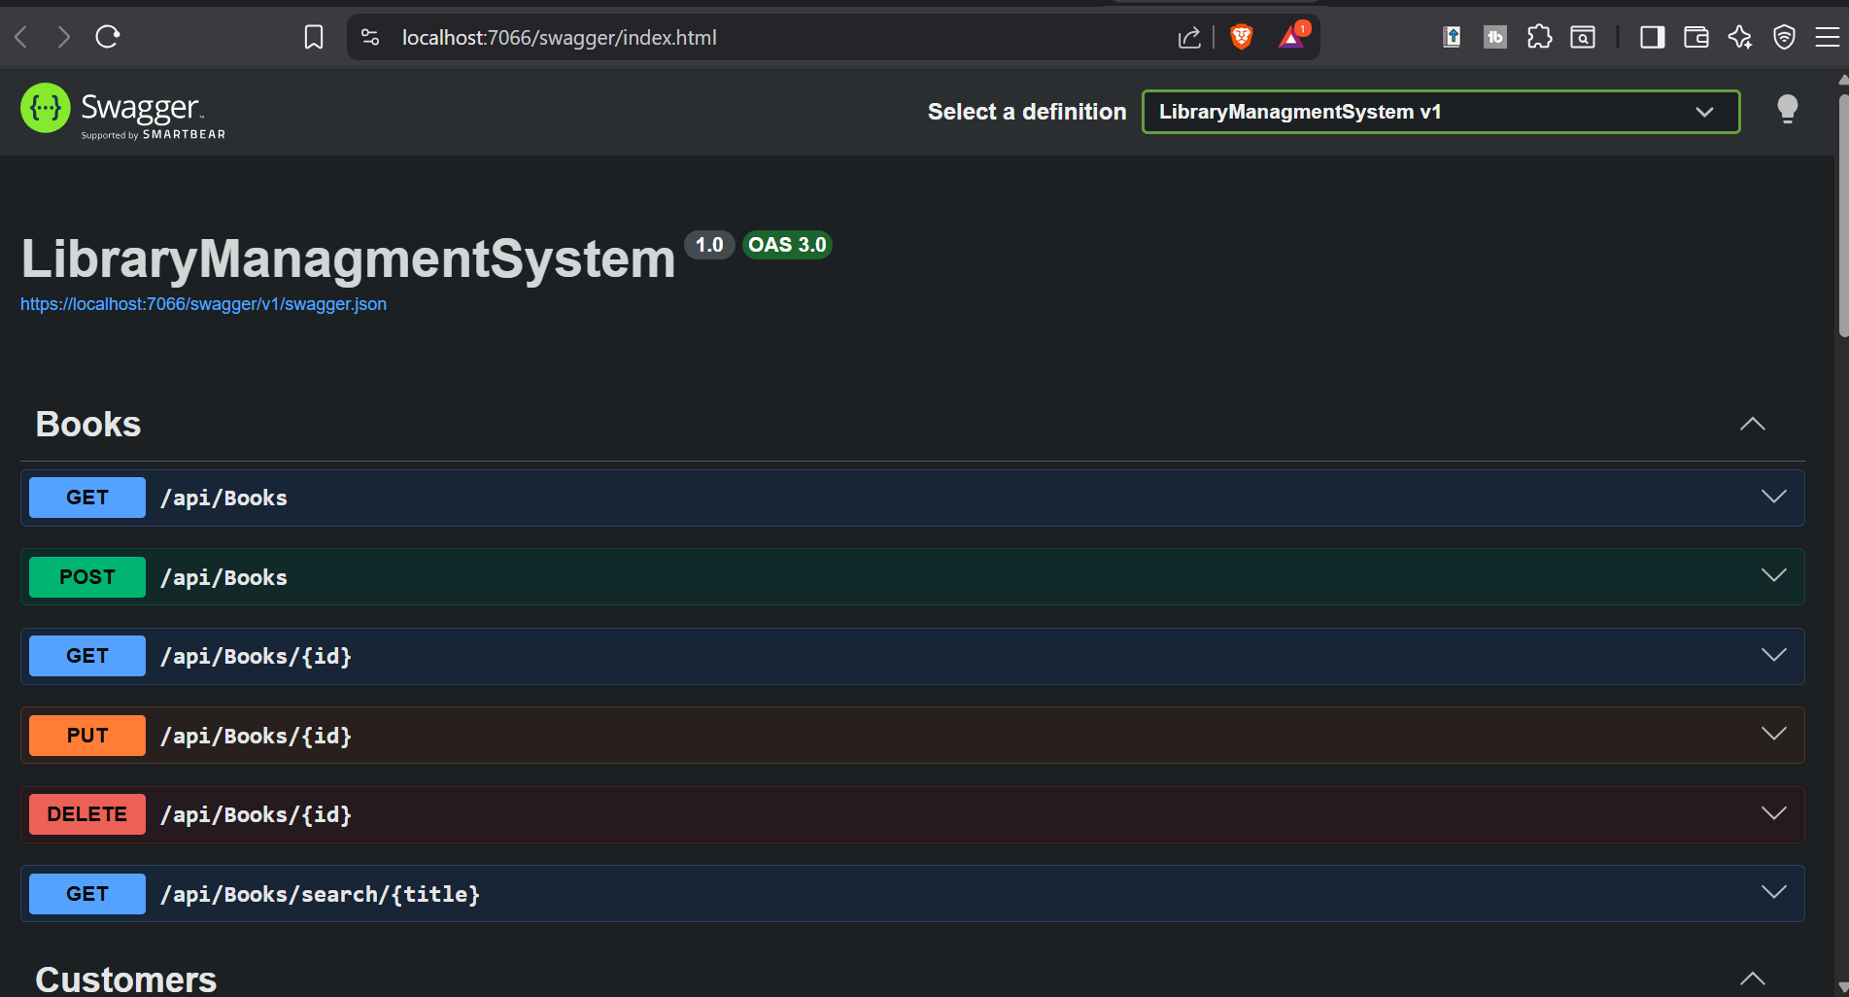
- (Figure 0, Book API end points)
- (could not show all end points as they alone could fill a page or two)
- Frontend:
- A responsive web interface built with React, Vite, and Bootstrap.

  - The First Entity: Employee
These are our Users and workers of the system, This Entity represents the staff members using the application to manage the library. (EmployeeId, FullName, Username, Password, Phone, and Email)
- Back End Swagger: Full CRUD operations
- 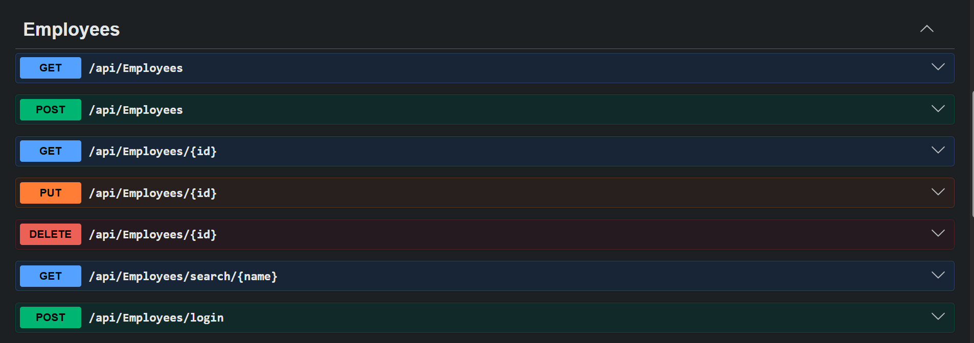
- (Figure 1 Employee API end points)
- Log in:
- For the login system, I opted not to create a separate database table or a dedicated login model containing only a username and password. Instead, the authentication process reuses the main Employee model.
- 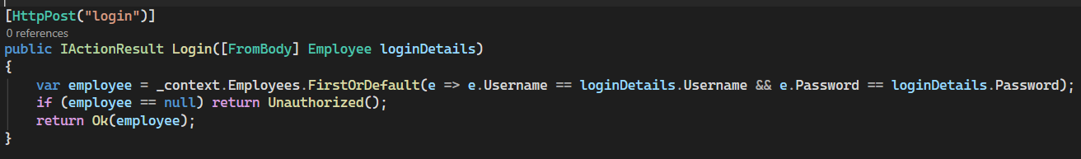
- (Figure 2, employee login C# back end)
- Frontend Implementation of login
- Frontend Implementation: The login form only collects the Username and Password. However, because the API expects a complete Employee object, the React frontend automatically packages these real inputs with dummy data (e.g., setting employeeId to 0 and using placeholder strings) to satisfy the payload requirements.
- 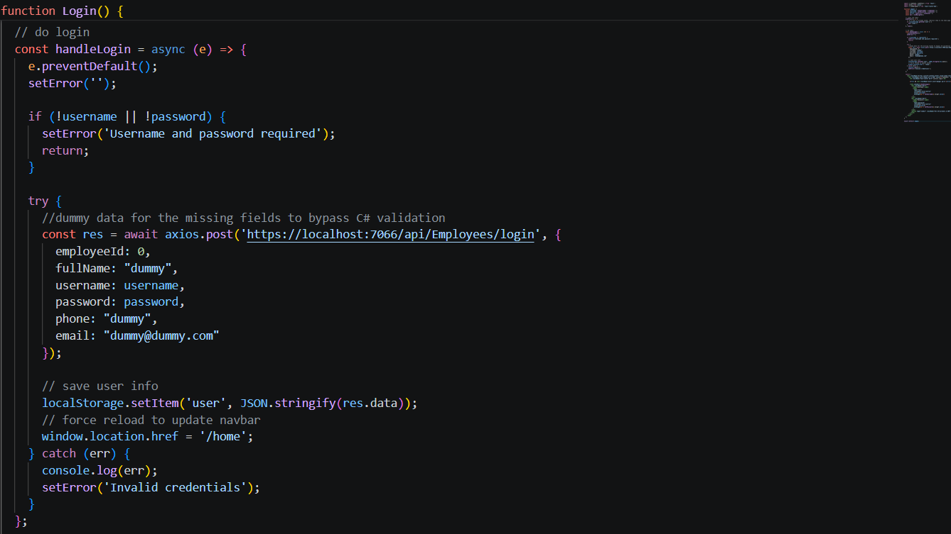
- (Figure 3, employee login React front end)
  - The Second and Third Enties: Customer and Book
Book represents the physical inventory available in the library,
Customer represents the library patrons who check out books
- Book Entity:
- Before a new book is added to the database, the system verifies that the PublishedYear is not set in the future and checks the database to ensure that no two books share the exact same Isbn. If a duplicate ISBN is detected or fields are missing, the API safely rejects the request with a BadRequest status.
- 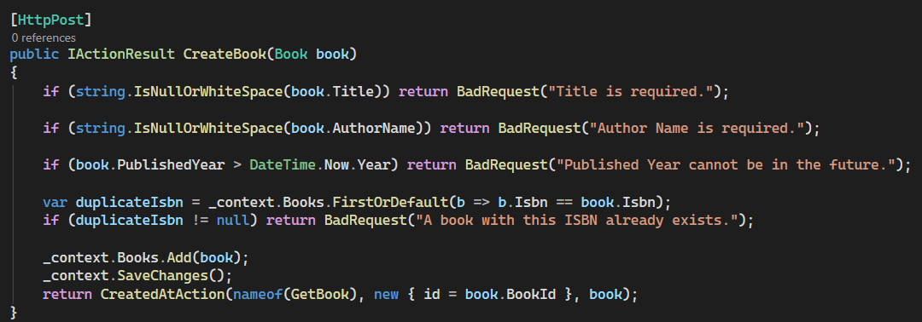
- (Figure 4, Book get API)
- Customer Entity:
- the CustomersController features a dedicated search endpoint (api/Customers/search/{name}). This utilizes Entity Framework's LINQ .Where() and .Contains() methods to allow library staff to dynamically filter the database, searching for patrons by typing portions of their FullName.
  - The Fourth Entity: Loan
It stores the LoanId, LoanDate, ReturnDate, and a boolean IsReturned status to track Loan progress.
- Relationship:
- A Loan belongs to one Book, one Customer, and one Employee (the staff member who issued it)
- Backend Business Logic:
- Active Loan Check: It prevents a book from being loaned out if it is already attached to an active, unreturned loan
- Time Limits: A book cannot be loaned out for more than 6 months, and return dates cannot be set in the past relative to the loan date.
- Retroactive Loans: It features a custom createRetroactiveLoan endpoint that allows staff to log past loans, enforcing that the retroactive date cannot be in the future.

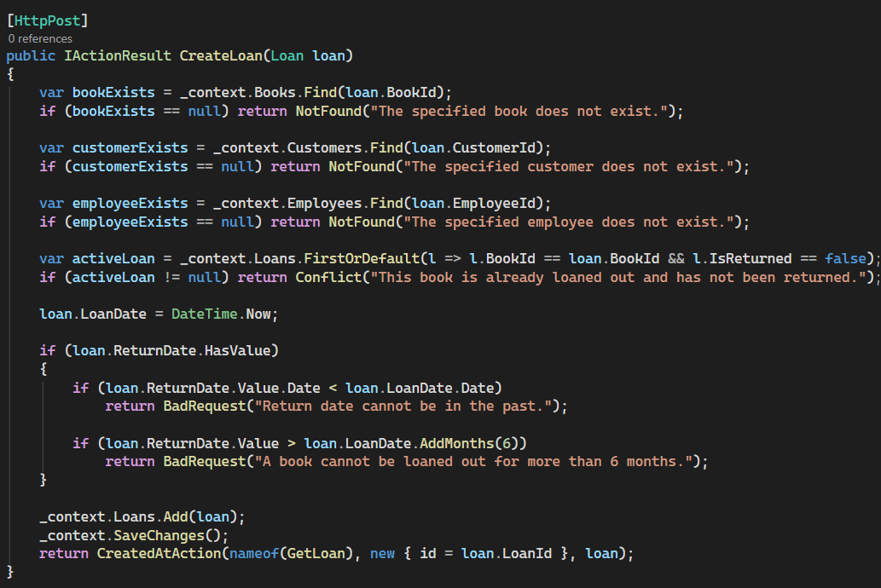
(Figure 5, Loan Post API)

